
Politecnico di Milano – V Facoltà di Ingegneria

075274 e 070644 - Sistemi distribuiti (con laboratorio)
Prof. G. Cugola

Appello del 22 Febbraio 2010
Rules:
- You are not allowed to use books, notes, or other material.
- You can answer in Italian or English.
- Total time for the test: 2 hours.

- Implement in Java a program to find the smallest value in an array of 10000 doubles, each known to be greater or equal to 0. To speed up operations, the program uses 4 threads to find the smallest value, assigning each thread ¼ of the elements to process. Suppose the array is already full and write the code to find the smallest value, including the code for multi-threading and synchronization. Make your best to optimize the program for speed, reducing the need for un-required operations.

- Describe and compare the approaches for removing unreferenced entities in a naming system.

- Describe the algorithm for totally ordered multicast. Is this form of communication causally ordered? Justify your answer.

- Consider the system in figure, which is running a distributed snapshot. Suppose that every process works by adding the value held by the received messages to its internal state S. Process A started the snapshot sending the token to process B (already processed) and D (still to be processed).

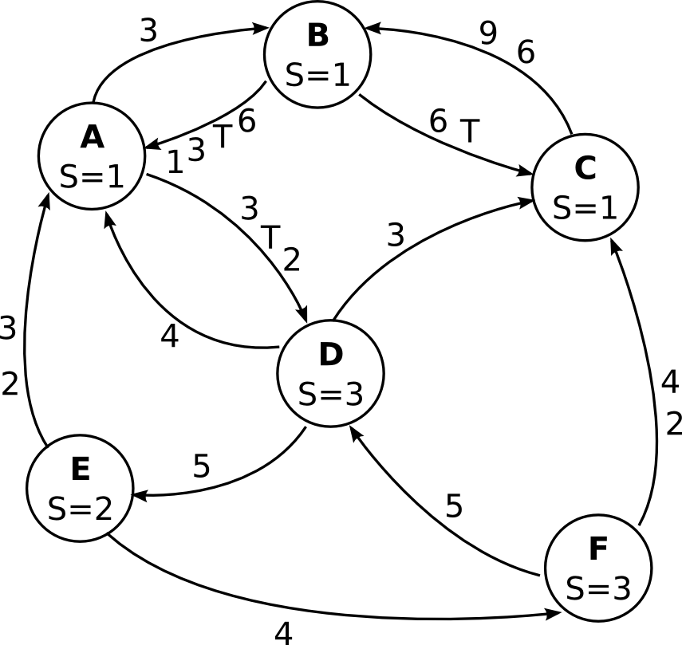

Assuming that no other operations occur apart those required to end the snapshot and that the output channel of B are much faster than the other channels, show the state captured by every node at the end of the snapshot (local state and messages recorded for each link).

- Describe the known approaches to obtain reliable communication in a group of non-faulty processes.
- Consider a distributed data store, as shown in figure. The store contains a numeric variable x, with initial value set to 0.

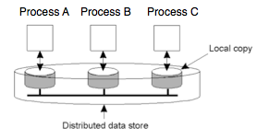

Three processes, A, B and C, interact with the store, running the following instructions.

A: while(true) {
if (x<3) x++;
}

B: while(true) {
if (x>0) x--;
}

C: while(true) {
if (x>0) x--;
}

The following requirement has to be satisfied: “Each process must always read a value of x between 0 and 3 (0 and 3 included)”
Consider 4 implementations (1, 2, 3, 4) with the following properties.

- The store presents a FIFO consistency model. Read and write operations are considered as separate instructions.
- The store presents a sequential consistency model. Read and write operations are considered as separate instructions.
- The store presents a FIFO consistency model. A read operation, the condition evaluation and the subsequent write operation are considered as a single atomic instruction.
- The store presents a sequential consistency model. A read operation, the condition evaluation and the subsequent write operation are considered as an atomic instruction.

In all implementations, when a write operation is performed, an identifier of the operation (and not the new value of x) is propagated to all replicas.
Write, for each implementation, if described properties are sufficient to satisfy the requirement. If not, show an example in which it is violated.

- Explain the issues in secure group communication, with reference to problems in joining and leaving a group. Describe and compare key distribution protocols (Logical Key Hierarchy, Centralized Flat Table).

